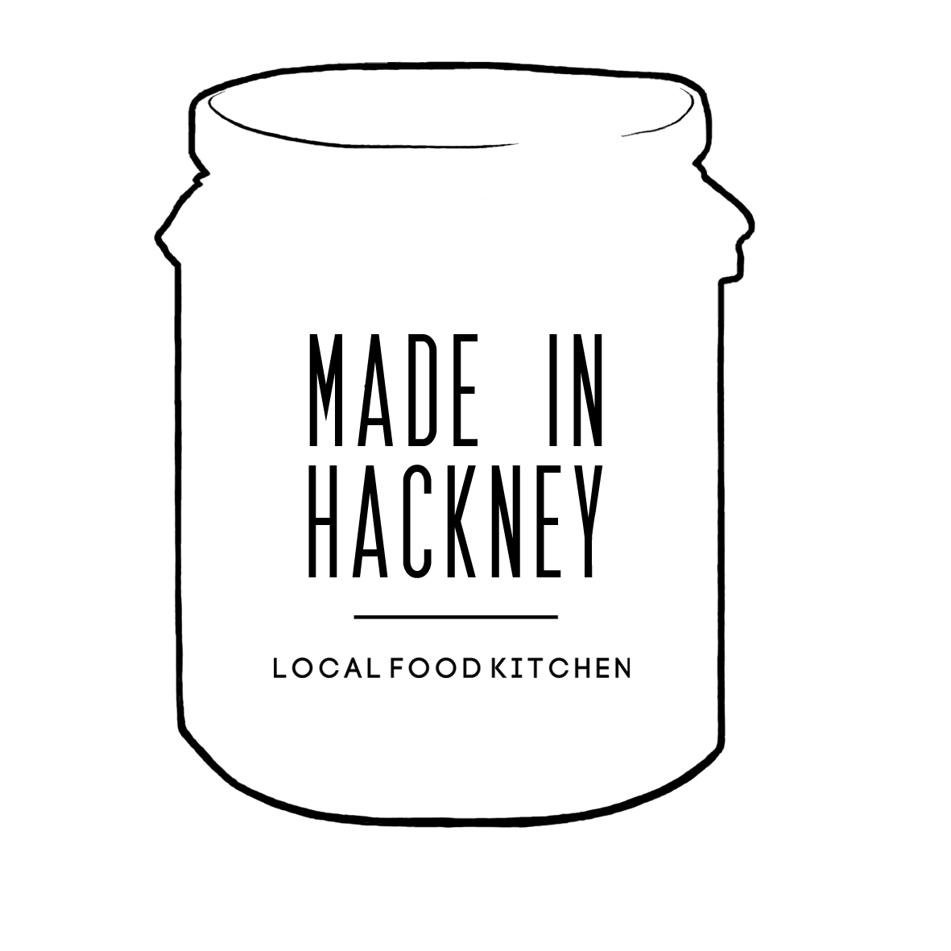
Kitchen Hire Booking Form
Made In Hackney is a vegan kitchen. This means we do not allow anyone to cook any dishes in the kitchen containing any animal products e.g. meat, fish, eggs, dairy, honey or anything edible that contains animal products such as non-vegan wine or beer, non-vegan sweets etc. We are happy to give advice on best ingredients to use to replace animal products in recipes.

1. Date Completing Form:

2: First Name: 3 Surname:

4: Organisation Name:

5: What type of ‘company’ are you?

- Workshop Leader (an individual with no formal company or employees) Y N
- Sole Trader or One Person Limited Company (no employees) Y N
- Company with employees who will be working in kitchen Y N

6: Requested Hire Dates & Times (Starting from when you will arrive and leave the kitchen):

The kitchen can be hired: Mon-Fri 9am-6pm, Sat 10am-6pm, Sun 11am-4pm
Special arrangements can be made for bookings outside of these hours.

Session 1: Session 2: Session 3: Session 4: Session 5:

Bookings longer than 5 sessions can only be made after an initial trial period of five sessions.

7: What Hire Rate Do You Qualify For?

Please note a £100 deposit is required to secure the booking. This can be paid in cash, BACs or Pay Pal. This is returned on completion of all scheduled bookings and MIH is satisfied with the standard of cleaning and condition of equipment. To qualify for half day/full day rates bookings must be for consecutive hours.

HIRE RATES – ALL ARE INCLUSIVE OF VAT

1: Standard Hire Charge Hour: £36 Half Day (4 hrs): £115 Full Day (8hrs): £202
Book with these rates: Y

2: Local Food Entrepreneur & Friend of MIH & Community Rate
To support start-ups, local 100% plant-based food entrepreneurs, friends of Made In Hackney and community groups, we offer special discounted hire rates. To discuss your booking with us and get a bespoke price contact us on: info@madeinhackney.org & andi@madeinhackney.org

3: Community Group/Charity Rate (Meetings only – no cookery equipment)
Rates: Hour: £18 Half Day (4 Hrs): £54 Full Day: £99
Book with these rates: Y

4: Community Group/Charity Rate (Cookery)
Rates: Hour: £27 Half Day (4 hours): £81 Full Day: £135
Book with these rates: Y

*Storage/freezer/fridge/cupboard space available to hire at weekly rate
*Bespoke discounts available for large block bookings of 5 or more

8. Using kitchen out of Food For All Shop Opening Hours (Mon-Fri 9am-6pm, Sat 10am-6pm, Sun 11am-4pm)

If booking the kitchen for less than 10 sessions and you will be leaving the premises later than 20 mins after the shop closes an additional ‘security fee’ of £25 per session will be applied to pay for a MIH member of staff to return to the premises to lock up.

Does this rate apply to your booking: Y N
Do you understand and agree to pay the £25 per session security fee?: Y N

9: Discounts

AMURT-UK & Food For All Shop Staff qualify for a 20% discount on kitchen hire bookings.

Volunteer led Community Class Leaders receive 20% discount on ONE kitchen booking at the Standard Hire Charge. If this applies to you and you’re booking the local food start-up rate you can claim 20% discount on the 6th session you book at the Standard Hire Charge after your Local Food Entrepreneur package has ended.

Do you qualify for this discount on this booking: Y

10: Cleaning

MIH is professionally cleaned several times a week with non-professional cleaning taking place every day as the kitchen is used. We can confirm on arrival the kitchen will be clean to a high and hygienic standard but may require a few small tasks such as a quick sweep of floor; a few pots put away; compost bin may need emptying into tumbler outside; recycling bin may need emptying…

Tick box to confirm you accept this condition: Y N
If you have ticked N we can arrange for the kitchen to be professionally cleaned prior to your booking at an extra cost of £15 per session.

Tick to confirm you would like this: Y N

All kitchen users must clean kitchen after usage and sign off the cleaning checklist before leaving.

11: Laundry

Made In Hackney has some lovely, branded Fairtrade, organic cotton aprons available to be used by you, your staff and workshop participants. Laundering costs are £1 per apron.

Number of aprons required:
Cost of apron usage per session:
If you do not wish to pay laundering costs please bring your own aprons.

12: Insurance

Employee Liability Insurance (Only to be completed by companies with employees)

Employee Liability (Clients other than workshop leaders, sole traders and one man limited companies will require employee liability in order to book the kitchen to £10million. Most insurance firms cover to £10million as standard).
Insured Title: Policy Number: Policy Period: Sums Insured:
Food Registration Number:
Public Liability Insurance: All clients need public liability of a minimum amount of £1 million.

Insured Title: Policy Number: Policy Period: Sums Insured:
Liability Quote Required:

13. Food Hygiene
Do you (and your team) who will be handling food have a current Food Hygiene certificate? Y N

Have you registered with Hackney Council to allow you to provide food to the public? Y N
Application in progress

If yes, what is your star rating?

14. Cancellation Policy

There will be NO refund for cancellation 7 days or less in advance of the reservation. 50% refund for cancellations made 8-10 days in advance of the reservation of each session. Full Refund for cancellations made 11 days or more in advance. Refunds will be paid within 30 days of cancellation. A cancellation charge of £50 (50% of the deposit) will be charged to cover admin fees, staff time taken make the booking and potential loss of other customer who have been turned down to hire the kitchen on those dates.

*As it is unlikely that we will be able to re-hire the kitchen with less than 10 days notice this refund policy is necessary to ensure the continued ability of Made In Hackney to fund our vital free programs to the community.

The Legal Bit

Nothing in this agreement or in the conditions will be treated as creating any tenancy, lease or any relationship of landlord and tenant between you and Made In Hackney. I have read and understood the kitchen conditions and to which this kitchen agreement is subject. My signature and initials at end of the form indicate acceptance of the terms of the agreement and conditions. Made In Hackney retains the legal right to cancel your bookings without completion of all booked sessions. New customers will be asked for payment in full upfront.

Client Signature: Client Position:

Signature on behalf of Made In Hackney:

Date Signed:

To be completed by Made in Hackney Finance Manager

Agreement Number:
Charge Rate & Discounts That Apply:
Number Of Bookings And Time Slots:
Hours Of Professional Cleaning:
Total Laundry Costs:
Start Date: Payment Period: Total Booking Fee: Paid In Full: Y
Deposit: Remainder Of Payment Due Date:

