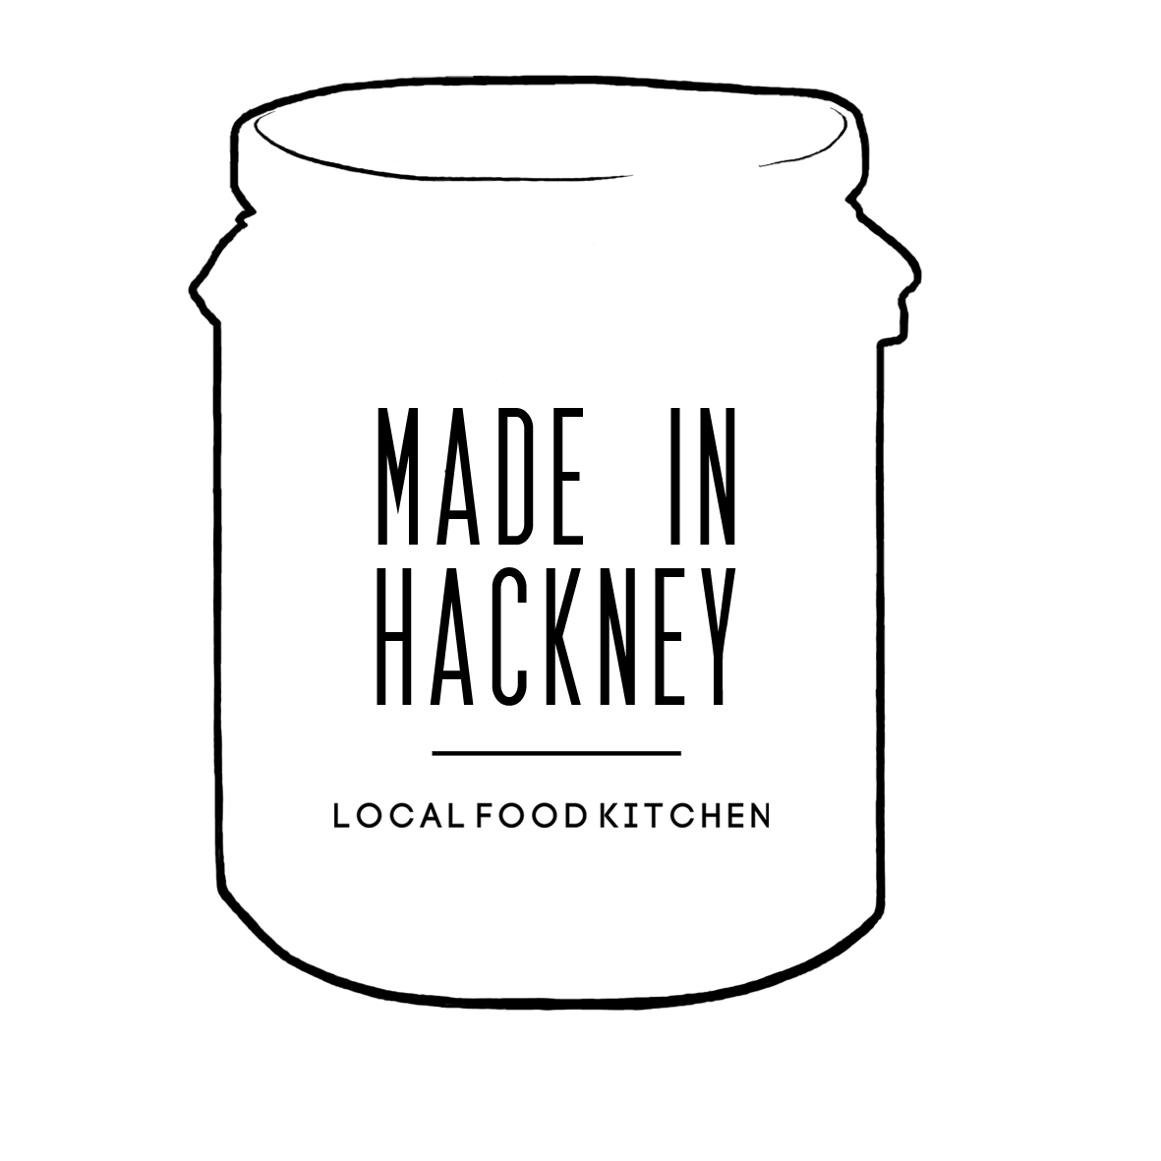

Kitchen Hire/Usage Rates

The Made In Hackney is available to hire for:

- Small food businesses and start-ups to create batches of products
- Food lecturers/teachers to lead courses and workshops
- Media/Creatives for photo/video shoots
- Organisations/companies to hire for team meetings, team building exercises, cookery demo’s
- Community groups/charities to have meetings/make food products

Deposit: £100 in advance of booking.
To be returned after completion of all booked sessions and MIH is satisfied cleaning procedures adhered to and all equipment is in good working order.

HIRE RATES – ALL ARE INCLUSIVE OF VAT

1: Standard Hire Rates
Hourly Rate: £36 p.hour. Half Day (4 hours) = £115
Full Day: (8 hours) = £202 p.day (8 hrs)
*Storage/freezer/fridge/cupboard space available to hire at weekly rate
*Bespoke discounts available for large block bookings of 5 or more

2: Local Food Entrepreneur Rate

To support start-ups, local 100% plant-based food entrepreneurs, friends of Made In Hackney and community groups, we offer special discounted hire rates. To discuss your booking with us and get a bespoke price contact us on: info@madeinhackney.org & andi@madeinhackney.org
3: Community Group Rate (Meetings Only)
Hire without use of electrical cookery equipment (meetings): £18 p.hour.
Half Day (4 hours): £54
Full Day (8 hours): £99 p.day.
*Storage/freezer/fridge/cupboard space available to hire at weekly rate
*Bespoke discounts available for large block bookings of 5 or more

4: Community Group/Charity Rate (Cooking)
Hourly Rate: £27
Half Day (4 hours): £81
Full Day (8 hours): £135
*Storage/freezer/fridge/cupboard space available to hire at weekly rate
*Bespoke discounts available for large block bookings of 5 or more

Hiring The Kitchen Out Of Food For All Opening Hours

(Mon-Fri 9am-6pm, Sat 10am-6pm, Sun 11am-4pm)
If you’re booking the MIH kitchen for less than 10 sessions and you will be leaving the premises later than 20 minutes after the shop closes an additional ‘security fee’ of £25 per session will be applied to pay for a MIH member of staff to return to the premises to lock up.
20% Discounted Hire Rate Applies To:
-Food For All & AMURT staff/members for their own enterprises
-Unpaid volunteers who have led a Sunday workshop (discount applies for one kitchen booking only)

MIH Cancellation Policy
There will be no refund for cancellation 7 days or less in advance of the reservation. 50% refund for cancellations made 8-10 days in advance of the reservation. Full Refund for cancellations made 11 days or more in advance. Refunds will be paid within 30 days of cancellation. As it is unlikely that we will be able to re-hire the kitchen with less than 10 days notice, this refund policy is necessary to ensure the continued ability of Made In Hackney to fund our free programs to the community.
User Policy Check List

To ensure the success of the kitchen project for the benefit of all the community user groups must commit to the following:

Adhere to kitchen/shop security guidelines (see policy)
(If using outside Food For All opening hours and no MIH staff present designated group ‘lead’ to open and lock shop (including during kitchen use); greet and accompany all users through shop into kitchen and vice versa at end of session. Users never to be left unaccompanied in shop. Phone calls/air can be taken outside kitchen at basement level.)

- Adhere to kitchens Health and Sustainability Guidelines (see policy).

- Complete all activities on and sign cleaning check list

- Complete user evaluation sheets needed for funders

- Do NOT bring into the kitchen or cook dishes using meat, fish or eggs.

